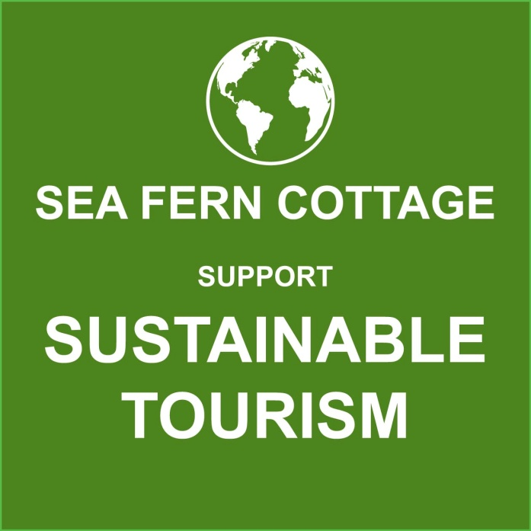
SUSTAINABILITY
At Sea Fern Cottage we are on the path to becoming a sustainable accommodation and we are proud to be doing what we can for the environment!
1. When you stay with us we keep you warm and save energy thanks to our new roof, which is well insulated. The Breather Quilt used is manufactured using 72% recycled materials and is made in the UK.
2. We recommend Sustainable travel – the beach, our recommended walks and bike rides can all be enjoyed from our doorstep, reducing road miles. We advocate our local bus route, so that guests know they can reach local villages and attractions using public transport.
3. We support local food producers by including products from Botham's Bakery, Yorkshire Tea and Yorkshire Crisps in our welcome basket. Making sure our guests know about local shops like Radford's Butchers in Sleights and restaurants is important to us and helps reduce road miles.
4. We’re working towards saving water – our toilets are dual-flush and our towels are easy launder using less water and energy.
5. We reduce waste – the toilet rolls, soaps, bath soaks and hand lotions we use are plastic free and we make it easier for our guest to recycle with clear labeling about what can be recycled by North Yorkshire Council.
6. We use 'Cleaner and Greener', a cleaning company that use eco friendly cleaning products and steam clean our hard floors.
7. We provide a ‘heated clothes airer’ rather than a tumble drier, so that our guests can help us to save energy and we have a system, so that bedding and towels that are not used don't get laundered un-necessarily.

